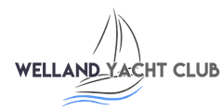
WELLAND YACHT CLUB
River Bank, Spalding, Lincolnshire, PE11 3AA
Affiliated to the Royal Yachting Association

RYA LEVEL 2 SAFETY BOAT COURSE

PRE COURSE INFORMATION

This course teaches recovery techniques for various craft and fleet management After this course candidates will be able to provide safety cover in a racing or training environment.

Course content
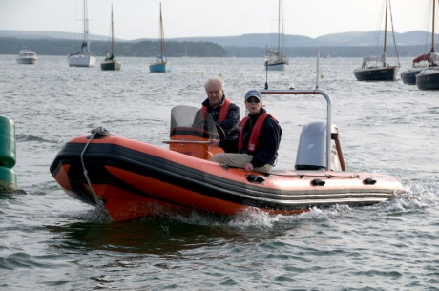
Preparation – launching and recovering; safety equipment, lines and fenders and fuel tanks
Boat handling – Position of boat and slow speed boat handling
Theory & Background – Learn the methods to safely recover crew from capsized boats and provide safety cover

Facilities and equipment
You will be using a combination of console-steered rigiflex boat. The Welland Yacht Club and the River Welland offer a varied learning environment to ensure all your tuition needs are met.
Please bring suitable clothing including wind and waterproofs with you.

Lunch
Lunch is not available so please bring a packed lunch which may be eaten in our well equipped clubhouse.

Pre Requisites
RYA Powerboat 2. The minimum age is 16 years old. Under

Duration
The course is a 2 day course and will run approximately from 9am to 5pm with 16hrs of training
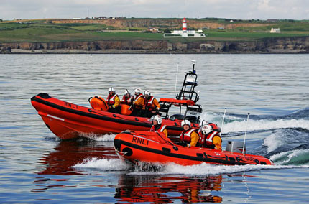
Running times
9.00-1.00 Session 1
1.00-2.00 Lunch
2.00-5.00 Session 2

Cost
£250 per person with 2 people or more
£300 One To One

Pre set course dates
Please enquire at Welland Yacht Club or on our website – www.wellandyachtclub.co.uk.

General
Please arrive early on the first day of your course to allow time for booking in and introductions to be done. Although Welland Yacht Club endeavours never to cancel a course please be aware that sessions are subject to appropriate safe weather conditions.

The next step
When you have completed the Level 2 course and are actively involved in a watersports environment with a club or organization you may wish to think about working towards your Safety Boat qualification.

