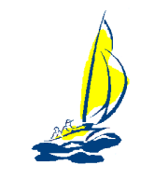
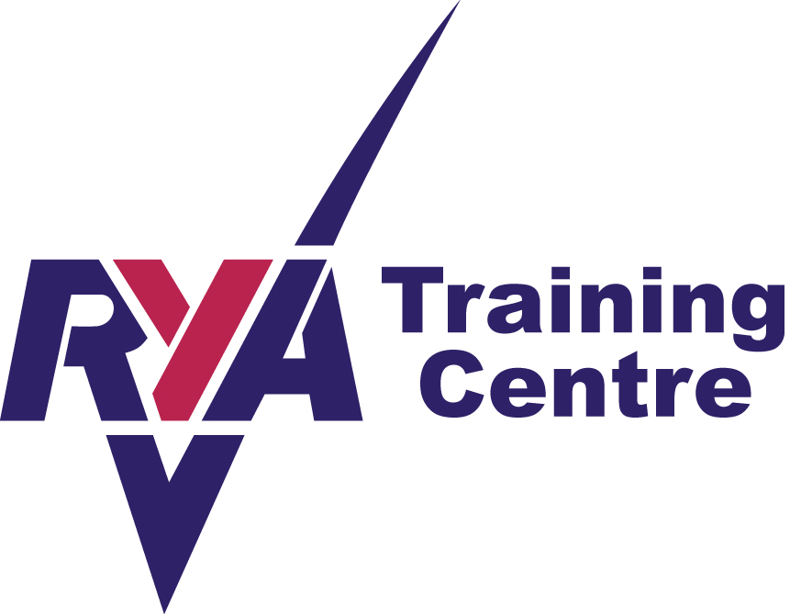
WELLAND YACHT CLUB
River Bank, Spalding, Lincolnshire, PE11 3AA
Affiliated to the Royal Yachting Association

RYA LEVEL 1 DINGHY SAILING
PRE COURSE INFORMATION

The Level 1 dinghy sailing course is the introductory level in the adult sailing scheme. The course is designed to give the complete novice the basic skills and knowledge needed to get afloat and start enjoying this wonderful sport.

This course may be run in conjunction with the level 2 sailing scheme please enquire for details

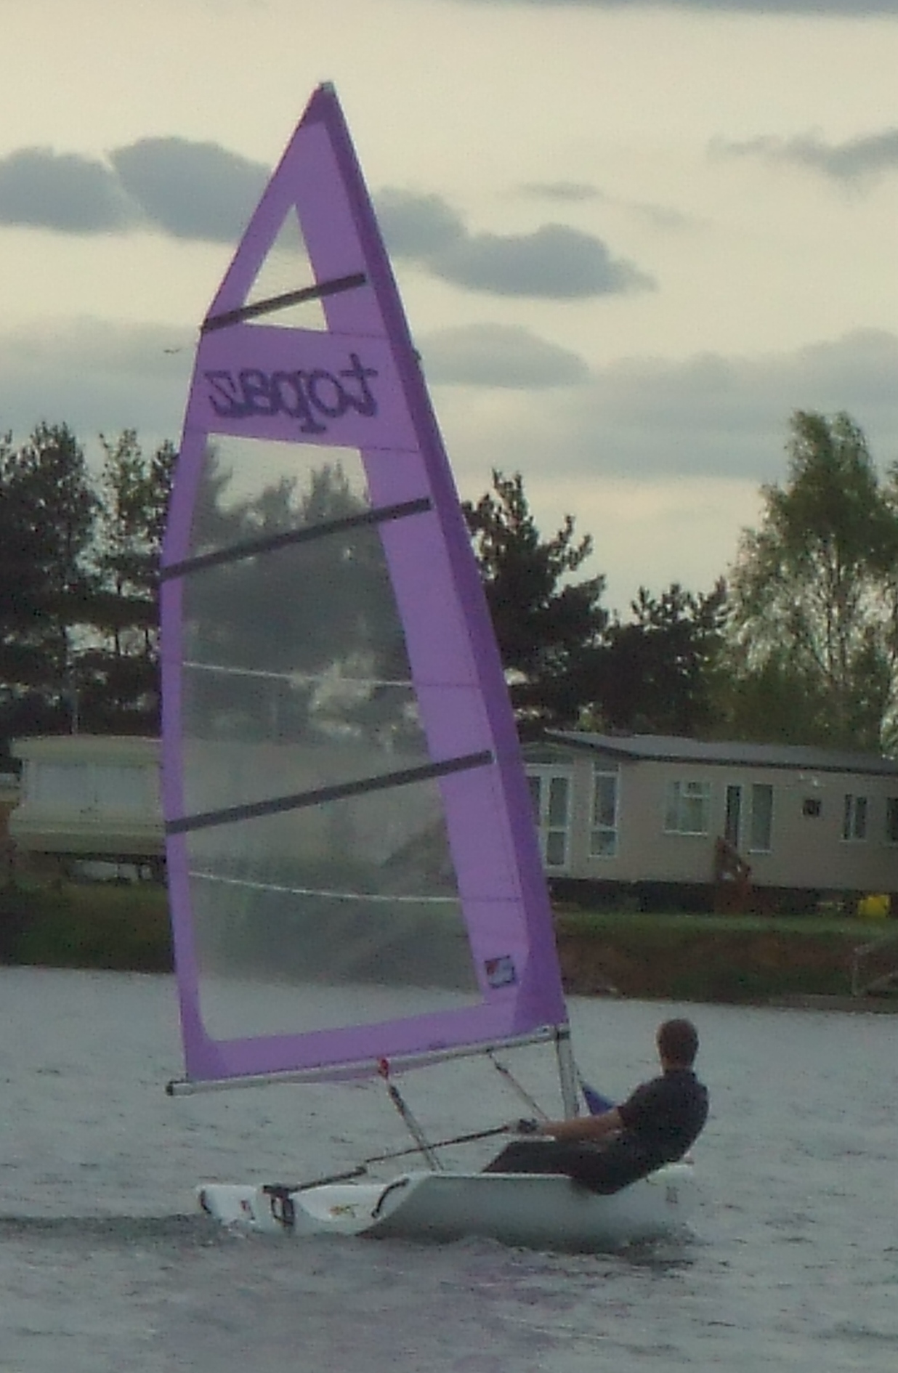
Course content
Introduction to sailing
Rigging
Reaching (sailing across the wind)
Sailing up and down wind
Launching and recovery
Sailing across the wind
Theory
Capsize recovery theory

Facilities and equipment
During the course you will be using a variety of craft. Our fleet consists of Magno, Graduate, Mirror, Topper, Pico, Optimist. The relevant boat will be selected to run your course
Buoyancy aids are provided for the duration of all courses and some wetsuits are available
Welland Yacht Club operates on the River Welland to the south of Spalding and provides a good learning environment for all your tuition requirements.
Please bring with you a towel and a pair of old trainers you don’t mind getting wet!

Lunch
Lunch is not available so please bring a packed lunch which may be eaten in our well equipped clubhouse.

Pre requisites
You must be at least 16 years old, and be enthusiastic about water sports
YOU DON’T NEED TO BE ABLE TO SWIM JUST BE WATER CONFIDENT

Duration
The course is run over two days with approximately 4 hours of tuition per day.
This course can also be combined with the Level 2 course to be run over a 3 or 4 day period

Running times
10.00 - 12.00 Session 1
12.00 - 1.00 Lunch
1.00 - 3.00 Session 2

Cost
£120 per head with 2 or more participants
£200 1:1

General
Please arrive early on the first day of your course to allow time for booking in and introductions to be done. Although Welland Yacht Club endeavours to never cancel a course please be aware that sessions are subject to appropriate safe weather conditions.

The next step
Having completed your RYA Level 1 why not try the Level 2, this course will progress your skills further and encourage you to sail more and more without the guidance of an instructor, the level 2 is classed as your ‘drivers licence’ in sailing. Once obtained you may hire any of our fleet of boats in light to moderate winds.

